
NAME OF THE TOPIC
Your Name

PAPER IDENTITY

TOPIC
______________________________________
GROUP NAME
______________________________________
LIST OF MEMBER & STUDENT ID
______________________________________
CLASS
______________________________________
DEPARTMENT
______________________________________

A. Topic description
Present the short description about the topic (between 100 – 200 words)
B. Summary concept of the topic
Present a summary about concept of the topic. Example: if your topic is cube number, then present the concept of cube number. Start with what is cube number, example of cube number, how cube number usually has been used, and etc.
C. Basic competencies, indicator, & learning objective
Write the basic competencies, indicator, and learning objective do you use with the topic. I recommend looking at national curriculum.
D. How to teach
Present the way you give the mathematics content (depending on the topic). Find an idea or the best way to learn the topic. Example: if I teach cube number, the I will be present unit of cube.
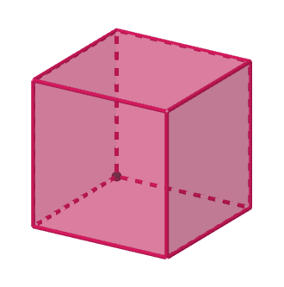 | 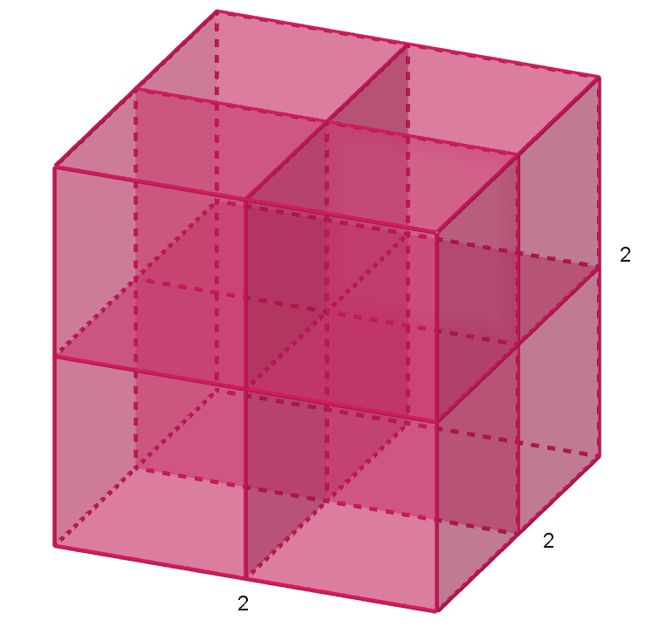
1 cube | 8 cubes

Then I will work with the several step:
1) counting the unit of cube manually
Description:
2) counting each layer
Description:
3) counting the sum of layer
Description:
4) counting 1 layer but this time use multiplication
Description:
5) find the relationship between cube on each layer and the number of layers with the number of cubes
Description:
E. Strengths and weaknesses
Explain the strengths and weaknesses of the idea.
F. STUDENT WORKSHEET
Create student worksheet: 1) identity; 2) rule; 3) problem; 4) space to answer

